Account Expiration Feature in KFS

KFS does not allow for an account to be closed until it has a zero cash balance and zero encumbrances. Many times, there is a desire to stop expenses from posting on an account before the account can actually be closed.
To facilitate the timely closing out of accounts, expiration date and continuation account features have been tested and implemented. The account expiration feature functions in a similar manner as the old accounting system’s temporary close. Once an expiration date is entered on an account, charges may be directed to the continuation account.

There are two different “paths” for expenses depending upon their source of origin, for example whether they are processed through KFS for a legacy system (non-KFS system).

Document Overview
KFS Transactions on Expired Accounts
Legacy System Transactions on Expired Accounts
Designated Transactions Which Always Post to Expired Accounts
Identifying Expired Accounts
Using the Account Expiration Feature
Continuation Account New Feature – Clearing Accounts
eData Reports

KFS Transactions on Expired Accounts
When you enter an account that has an expiration date into a KFS edoc and click “ADD” on the transaction line, you will receive the following message: Account 4XX-XX-XX has expired. Please override to use it anyway, or use the recommended continuation account IS 902-XX-XX, or use a different account.

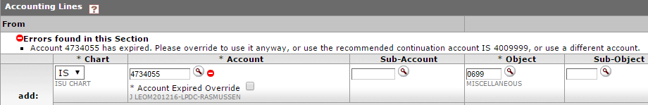

The options are:
- Override the Account – this option should be used if you DO want the financial transaction to post to the account. For example, it may be past the award’s end date, so the expiration date was entered to prevent future expenses from posting. However, there may still be an outstanding subcontract invoice that you do want to post the account.
- Post to the Continuation Account – when an expiration date is entered, a continuation account must be entered as well. The options for continuation accounts include:
  - Unrestricted accounts – accounts such as 490 or 290 accounts
  - Clearing accounts –a special account (902-XX-XX) to be used solely for legacy system directed transactions on expired accounts. See Page 3 for more information.
  - Projects’ next year of funding account – in limited cases, it may be allowable for SPA to enter the account number of the next year’s funding for the project. Please consult with your SPA accountant to determine if this option would work for a particular project
- Use a Different (Unrestricted) Account – the originator may enter a different account number all together before submitting the edoc. Since the expense is associated with an expired project, the charge should go against an unrestricted account and not another SPA account. Remember, if the expense is related to more than one account, the expense should be properly allocated among the related accounts. Therefore, if Project A is expired, it is not allowable to charge the full expense to Project B because it is related. The charge should be allocated between Projects A & B, with Project A’s share charged to an unrestricted account.

Legacy System Transactions on Expired Accounts
Certain transactions are processed in systems outside of KFS. These types of transactions are typically batched and then fed into KFS. Some examples of these types of transactions include Bookstore, Central Stores, Transportation Services, etc. Some legacy systems will validate account numbers against KFS. If an account is expired, it will show as “closed” to the legacy system.

In those few cases where a transaction is fed into KFS from a legacy system on an expired account, the transaction will post to the continuation account. When the system automatically posts an expense to a continuation account the description will start with, “AUTO FR IS(expired account) DESCRIPTION.”

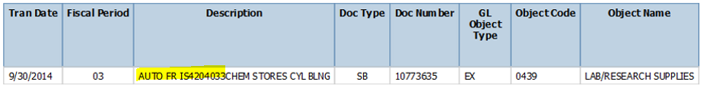

In this example, a Chemistry Stores charge tried to post to 420-40-33, but was directed to a continuation account instead.

Designated Transactions Which Always Post to Expired Accounts
Transactions which affect encumbrances have been uniquely set up to always post to the expired account, regardless if there is an expiration date entered or not. This is to ensure that encumbrance balances are properly cleared in the various systems. Transactions which will post to expired accounts include:
- Purchase Orders (PO)
- Vouchers (VO)
- Voucher Payment (VP) – ACH type transactions
- Payroll (PY)
- Payroll Encumbrances (PE)
- June Special Payroll (JY)

Identifying Expired Accounts
There are two ways to find out if an account is expired. First, you can look up the account in KFS:

Or you can look up the account on the Sponsored Programs Financial Report in eData:

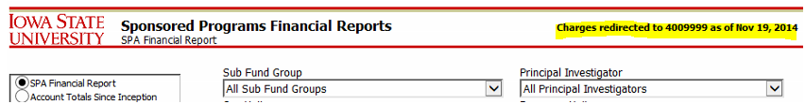

Using the Account Expiration Feature
Here are some general guidelines for using the account expiration feature:
- The expiration date can be the current date or any date in the future
- The expiration date does NOT have to match the end date of the award
- An expiration date can be applied temporarily when an account is overspent to keep additional expenses from hitting the account
- Travel and Telecom encumbrances should be removed before an account is expired
- Requests to expire an account should be sent to your SPA accountant

KFS Transaction Override on Expired Accounts
If you want the KFS transaction to post to an expired account, you will need to check the Account Expired Override box. This checked override box will show as the transaction routes through KFS so future approvers will know the transaction will post to an expired account.

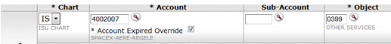

KFS Transactions to Continuation Accounts or Other Unrestricted Accounts
If the edoc originator receives the expired account message and wishes to have the transaction post to the continuation account or other unrestricted account number, the edoc originator needs to enter the alternate account number in place of the expired account. When using an alternate account number, SPA recommends entering the expired account number and brief explanation in the notes section so a record exists of where the charge was originally intended to post.

If the Continuation account number is a clearing account (902-xx-xx), the KFS edoc originator should not use that account number in lieu of the expired account. Instead, the edoc originator should contact the KFS Fiscal Officer of the expired account to determine where the expense should post.

It will be up to the department and colleges to determine their preferred business processes for managing KFS transactions on expired accounts.

Continuation Account New Feature – Clearing Accounts
A clearing account is a special account (902-xx-xx) established specifically to “catch” those transactions from legacy systems which try to post to an expired account. Only one clearing account will be established for each department. Departments are expected to review and move transactions from the clearing account on a monthly basis.

If your department has not yet established a clearing account and would like to do so, please contact Lana Jarvis at ljarvis@iastate.edu.

eData Reports – Continuation Account Numbers
There is a custom eData report which will show all open accounts with an expiration date entered, sorted by department. The report path is: Public Folders/Custom Reports/University Wide/KFS – Financial Reports/Continuation Account Numbers

