DRILLING TO FPM DOCS IN FIREFOX
e-Data reports may include links allowing you to click a reference ID number and then navigate to a Facilities Planning and Management (FPM) page.

For Example, in the Internet Explorer screen shot below:
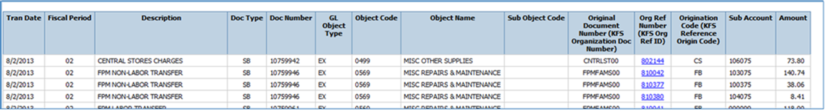

If we select Origination Code 810042, it renders this page:
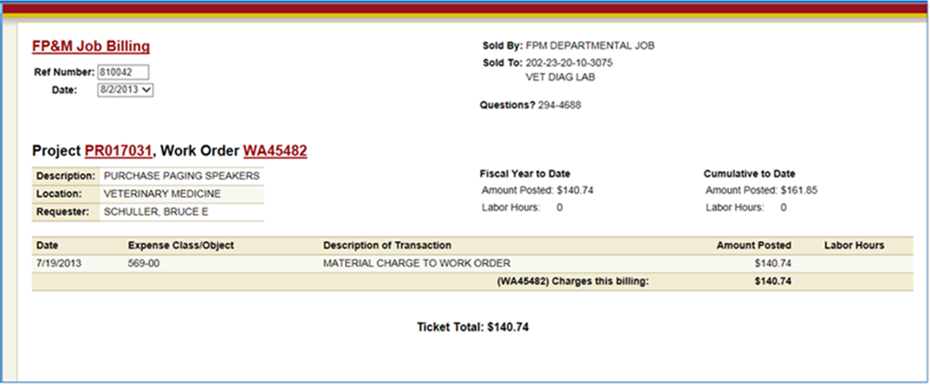

If we do this in Firefox, the FP&M page renders this page…

This is a result of Firefox blocking mixed content (http://blog.mozilla.org/security/2013/05/16/mixed-content-blocking-in-firefox-aurora/).
The FPM page includes a mix of HTTP and HTTPS resources, or mixed content. By default, Firefox blocks access to this type of page as a security measure.

To view a HTTPS page with blocked Mix Content, click on the sheild icon located on the address bar:

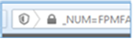

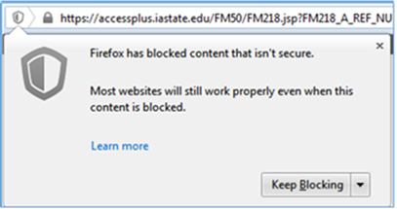

Select the dropdown arrow and change the setting to Disable Protection on This Page
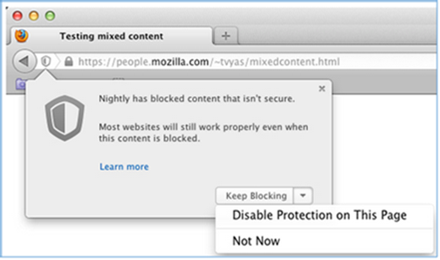

If you have further questions, please contact:

Kevin DeRoos
Information Technology Services
Iowa State University
kderoos@iastate.edu
515.294.8829

eReport Highlight:

eReports are still available in the same place, AccessPlus.

The report below is very useful for PIs because it includes both 4XX accounts and non-4XX accounts where the PI is the Account Manager in KFS (290, 490, 497, etc).

ACTG-Acct (heading)
ACTG-Acct Reports by Acct Mngr (report)
Enter the PIs name (Example “HALL”)

Looking at the Table of Contents on the report below, there is a 202 account with transactions during October. There are also two Sponsored Programs Accounts, both including a Sponsored Programs Financial Report. Note that the account will only list “Transactional Detail” if the account had activity in the selected month. For example, 4194024 did not have any activity in October and therefore does not show a Transactional Detail report.
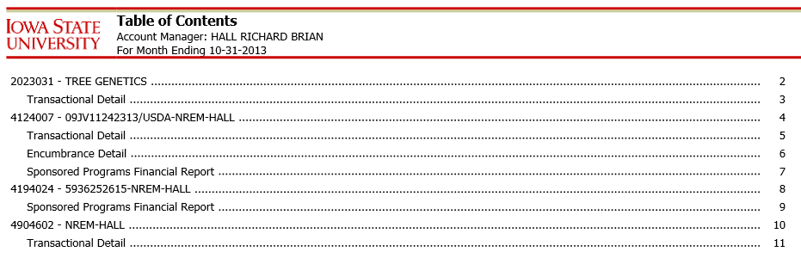
- This report is a PDF which can be emailed to PIs.
- We are working on some enhancements that would add available balances to the report.
- We are also working on adding this to one of the portals, where it would be available with real-time figures rather than month-end information.
- If you have a PI who is in charge of a subaccount, but is not in charge of the overall account, the subaccount will not show in this list. This list pulls only at the account number level by Account Manager.

Custom Report Highlights:
- Custom Report: BBMBS Financial Report
There are two custom reports created for Kelly Yohnke in BBMB, but may be useful for other grant coordinators. If there is interest, the reports could be added into University-Wide reports with the option to choose by department, org code, etc.

The first report is a consolidated report that renders in MS Excel, with one tab for each RU (LAS, CALS, AES, etc). The first example is a portion of the first tab. Columns B-F report at a summary level, Columns G-J report on a monthly level, and Columns S-V report on To-Date information in. Columns W-Y are places where Kelly can manually adjust her totals, make notes, etc.

This report provides a summary of a department’s 490 accounts where PIs can see their Balance minus Encumbrances.

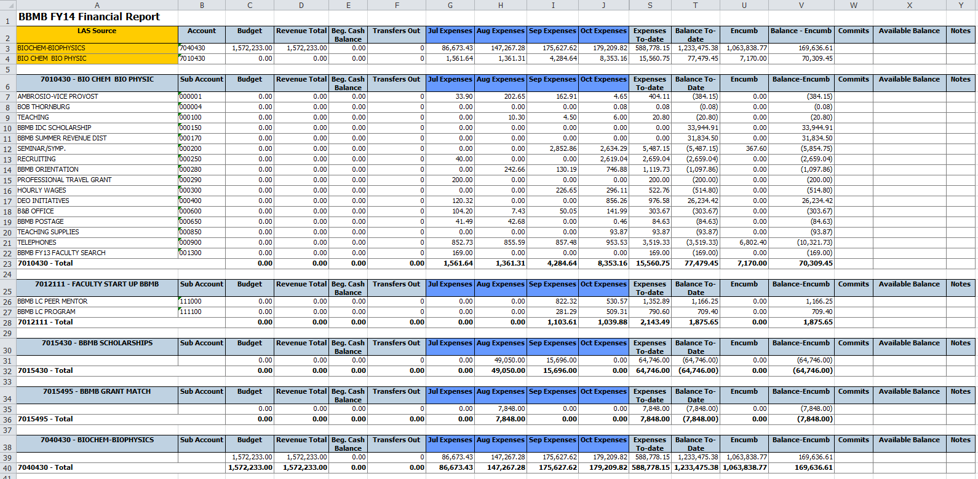
- Custom Report: BBMBS Reconciliation Report
Even though eData cannot provide the reconciliation feature many found useful in WebFM, a custom report was created which departmental administrators can use to reconcile their accounts at month-end.

First, select the month to be reconciled and the desired Fund Group of accounts to include. Then click Run.

Each account opens in a different tab with the transaction detail for that month. In columns P and Q, additional columns for “Recon” and “Notes” have been added so items can be checked off and notes can be made.

This is especially useful if several people reconcile different types of transactions and the report is stored on a shared drive.

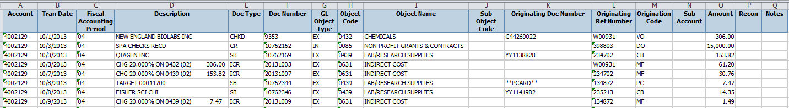

- Custom Report: University-Wide: Sponsored Funding Account Summary
- This report is very similar to the Cash Recap report in the SPA Financial Portal, BUT…
- The “Direct Cost Balance” assumes all future expenses would be subject to Indirect Costs. (see example below)
- Sort by options include Active Awards, Closed Awards, or All.
- Results can be sorted by Account, PI, or End Date.
- The report can be exported to Excel or PDF.
- Totals are up-to-date as opposed to the prior month-end total.
Example 400-29-04 (using October figures)
- Cash Recap Report: the “Unspent Balance” is $61,582.98 (which includes unspent Direct AND Indirect).
- SPA Financial Report: the “Unspent Balance” column shows the unspent direct, which is $44,312.47 as well as the Unspent Direct and Indirect of $61,582.98.
- Sponsored Funding Account Summary Custom Report: the “Direct Cost Balance” column shows $41,610.12, which is how much the PI could spend if future expenses were subject to IDC. This is also the amount we would use to zero the account if there was a small residual balance left in a fixed price award. ($41,610.12 x 1.48 = $61,582.98). This estimate is useful when expenditures for items that are not subject to IDC have been spent in a manner other than that of the original proposed budget.

